DEFINITIONS:

Hamiltonian path: A Hamiltonian path is a path that travels through every vertex of a connected graph once and only once.

OBS: Not every graph has a Hamilton path.

Hamilton circuit: A Hamilton circuit is circuit that travels through every edge of a connected graph (except at the end, where it returns to the starting vertex).

OBS: Not every graph has a Hamilton circuit.

Example:
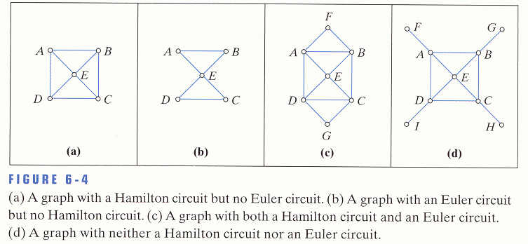

Hamiltonian circuit in (a): A, B, C, D, E, A;
(c): F, B, C, G, D, E, A, F.

Hamiltonian path in (b): A, B, E, C, D;
(c): F, B, C, G, D, E, A, F.
The graph in (d) has no Hamiltonian or Euler circuit or path.

