The acronym TSP stands for “traveling salesman problem”, so called because one well known variation is that of a traveling salesman who must call on customers in several cities and wants to find the most efficient route that visits each of the cities once, returning at the end to his home town. The name has stuck as a generic name given to all sorts of similar problems, even if they have nothing to do with traveling salespeople; so it is best to think of “traveling salesman” as just a metaphor.
The remarkable thing about TSPs is their deceptive simplicity. It just does not seem that finding an optimal route should be so hard! It is always a surprise to find out, as we soon will, that TSPs represent one of the most interesting, important, and complex problems in graph theory, if not all of mathematics. Understanding TSPs and what it means to “solve” them will be the main purpose of this chapter.

Example (page201): A Tale of Five Cities
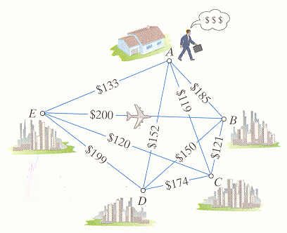
Willy Loman, a travel salesman, has 5 customers in 5 cities: A, B, C, D and E, and he is planning an upcoming sales trip to visit each of them. Willy needs to start and end the trip at his hometown A. The graph shows the cost of a one-way airline ticket between each pair of cities. Willy wants to know what is the cheapest possible sequence in which to visit the 5 cities.

